SULIT



SECP2523 DATABASE

SESSION 2024/2025 - SEMESTER 1
````

ALTERNATIVE ASSESSMENT REPORT: PHASE 2

Name | WOO CHENG SHUAN
IC No. / Matric No. | 040221-08-0056 / A23CS0283
Year / Program | 2/SECPH
Section | 01
Lecturer Name | DR. ROZILAWATI BINTI DOLLAH
Case Study | WBL PROJECT
System Name | KOPERASI KADA SYSTEM
Group Name | TECHNICRAB

SECTION C (SQL AND INTERFACE IMPLEMENTATION)

3.1 | SQL Statement (DDL & DML)
 |  | << Provide the SQL statements (DDL and DML) for a set of queries (minimum 10 queries) that can be implemented in your proposed module. In addition, please include the screenshots of the output/results for each SQL statement.>>
3.2 | Interface Implementation
 |  | << Provide at least THREE (3) interface design reflecting queries in Subsection 3.1.>>
SECTION D (CONCLUSION AND REFLECTION)

4.1 | Conclusion
 |  | << Provide achievement(s) that have been achieved in your module and suggestion(s) to further improvise in future .>>
4.2 | Reflection
 |  | << Provide your reflection based on your WBL project .>>

Table of Contents
SECTION C (SQL AND INTERFACE IMPLEMENTATION) 4
3.1 SQL Statement (DDL & DML) 4
3.2 Interface Implementation 8
SECTION D (CONCLUSION AND REFLECTION) 9
4.1 Conclusion 9
4.2 Reflection 9

SECTION C (SQL AND INTERFACE IMPLEMENTATION)

3.1 SQL Statement (DDL & DML)

CREATE TABLE EMPLOYEE (
employeeID INT PRIMARY KEY,
password VARCHAR(30) NOT NULL
);

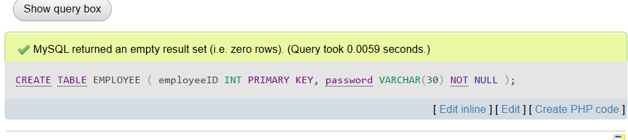

CREATE TABLE ADMIN (
employeeID INT PRIMARY KEY,
adminPassword VARCHAR(30) NOT NULL,
FOREIGN KEY (employeeID) REFERENCES EMPLOYEE(employeeID)
);
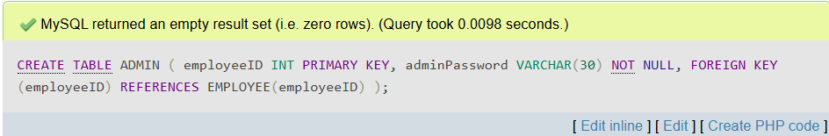

CREATE TABLE MEMBER (
employeeID INT PRIMARY KEY,
noPF INT NOT NULL,
memberName VARCHAR(80) NOT NULL,
ic CHAR(12) NOT NULL,
email VARCHAR(30) NOT NULL,
phoneNumber VARCHAR(15) NOT NULL,
sex CHAR(1) NOT NULL,
religion VARCHAR(30),
maritalStatus VARCHAR(15),
nation VARCHAR(30),
position VARCHAR(30) NOT NULL,
monthlySalary DECIMAL(10,2) NOT NULL,
FOREIGN KEY (employeeID) REFERENCES EMPLOYEE(employeeID)
);
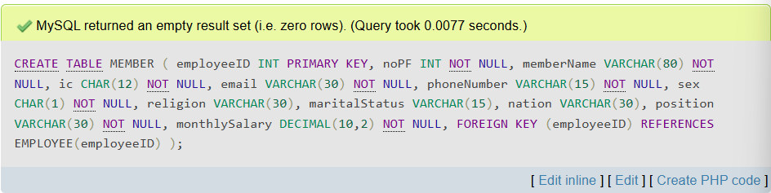

CREATE TABLE LOAN (
loanApplicationID VARCHAR(20) PRIMARY KEY,
financialType VARCHAR(30) NOT NULL,
amountRequested DECIMAL(12,2) NOT NULL,
financingPeriod INT NOT NULL,
monthlyInstallments DECIMAL(10,2) NOT NULL,
bankName TEXT NOT NULL,
bankAccount INT NOT NULL
);
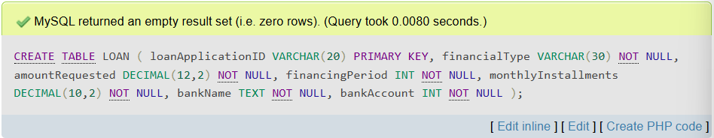

CREATE TABLE APPLICATIONDETAILS (
employeeID INT,
loanApplicationID VARCHAR(20),
applicationDate DATE NOT NULL,
loanStatus VARCHAR(20) NOT NULL,
loanApproveDeadline DATE NOT NULL,
PRIMARY KEY (employeeID, loanApplicationID),
FOREIGN KEY (employeeID) REFERENCES EMPLOYEE(employeeID),
FOREIGN KEY (loanApplicationID) REFERENCES LOAN(loanApplicationID)
);
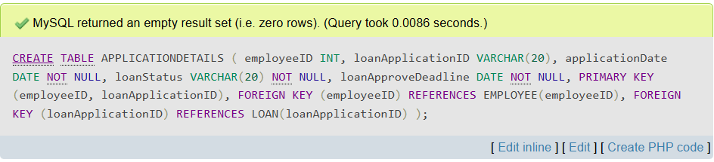

CREATE TABLE ALERT (
alertID VARCHAR(20) PRIMARY KEY,
alertType VARCHAR(20) NOT NULL,
alertContent TEXT NOT NULL
);
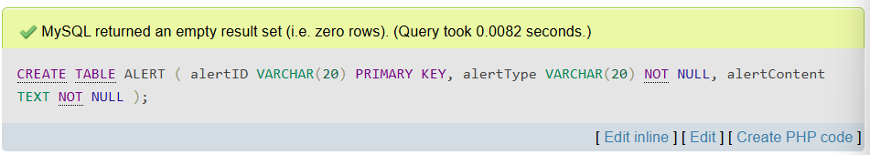

INSERT INTO EMPLOYEE (employeeID, password) VALUES
(0221, ‘chengshuan04’);
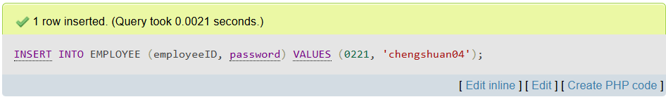

SELECT * FROM EMPLOYEE WHERE employeeID = 1234;
INSERT INTO EMPLOYEE (employeeID, password) VALUES
(1234, ‘securePass’);
INSERT INTO ADMIN (employeeID, adminPassword) VALUES
(1234, ‘kada2024’);
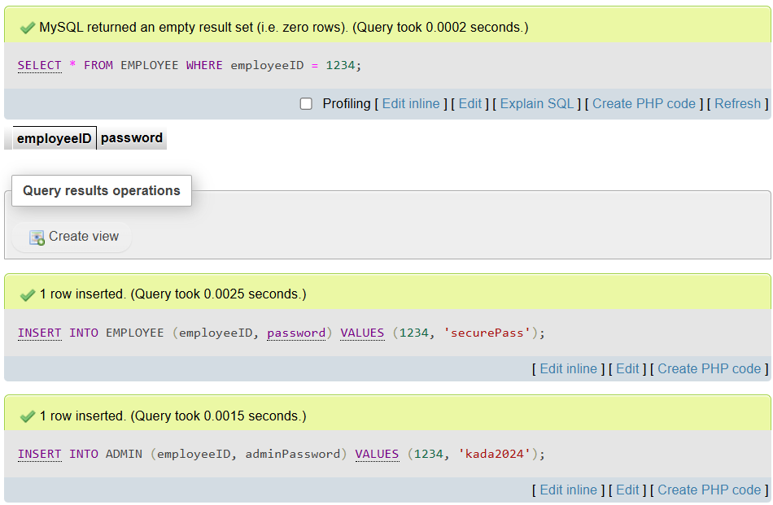

INSERT INTO MEMBER (employeeID, noPF, memberName, ic, email, phoneNumber, sex, religion, nation, position, monthlySalary) VALUES
(0221, 2211, ‘WOO CHENG SHUAN’, ‘040221080056’, ‘chengshuan0221@gmail.com’, 01170740302, ‘P’, ‘Buddha’, ‘Bujang’, ‘Malaysia’, ‘Data Engineer’, 3000);
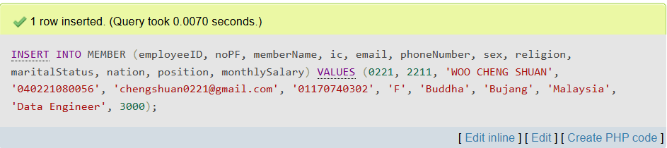

INSERT INTO LOAN (loanApplicationID, financialType, amountRequested, financingPeriod, monthlyInstallments, bankName, bankAccount) VALUES
(‘LA123456789’, ‘Personal Loan’, 30000, 36, 650, ‘RHB bank’, 123456789);
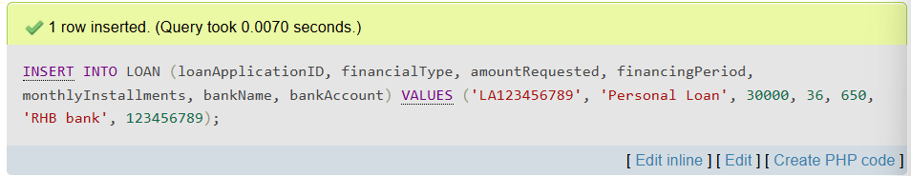

INSERT INTO APPLICATIONDETAILS (employeeID, loanApplicationID, applicationDate, loanStatus, loanApproveDeadline) VALUES
(0221, ‘LA123456789’, ’2025-01-26’, ‘Received’, ’2025-02-06’);
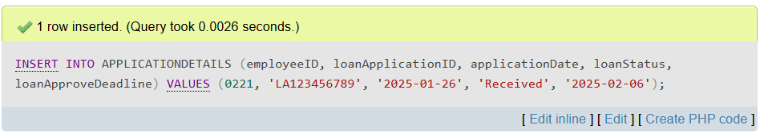

INSERT INTO ALERT (alertID, alertType, alertContent) VALUES
(‘A001’, ‘Deadline Reminder’, ‘A loan application validation deadline is approaching.’);
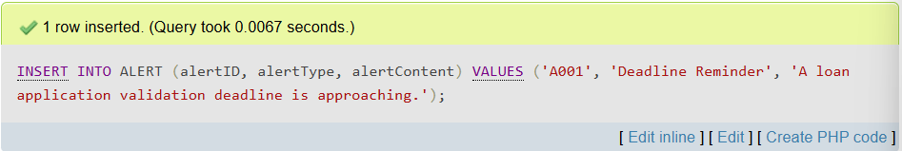

3.2 Interface Implementation
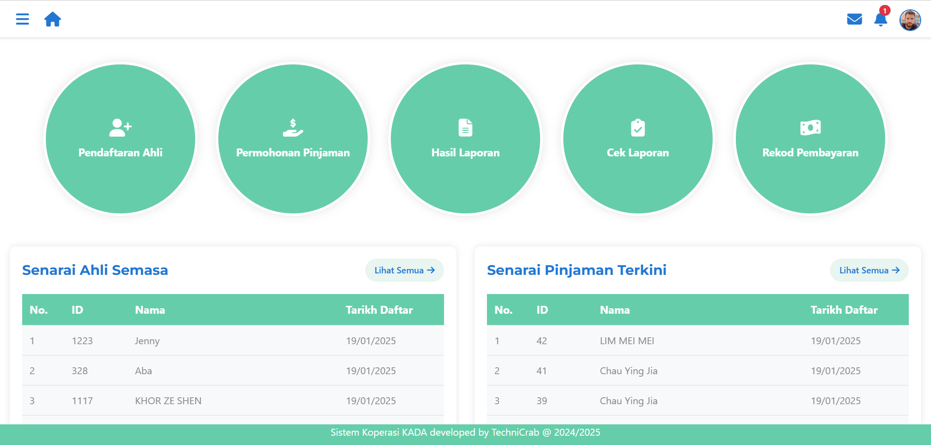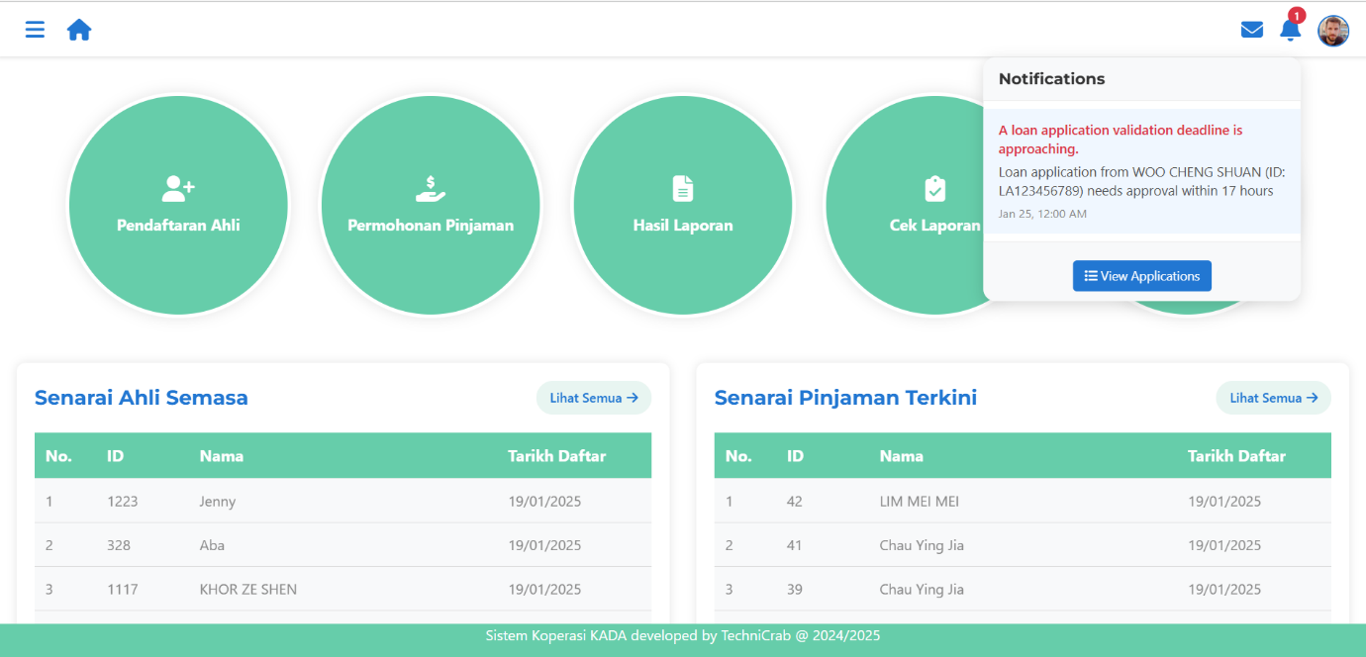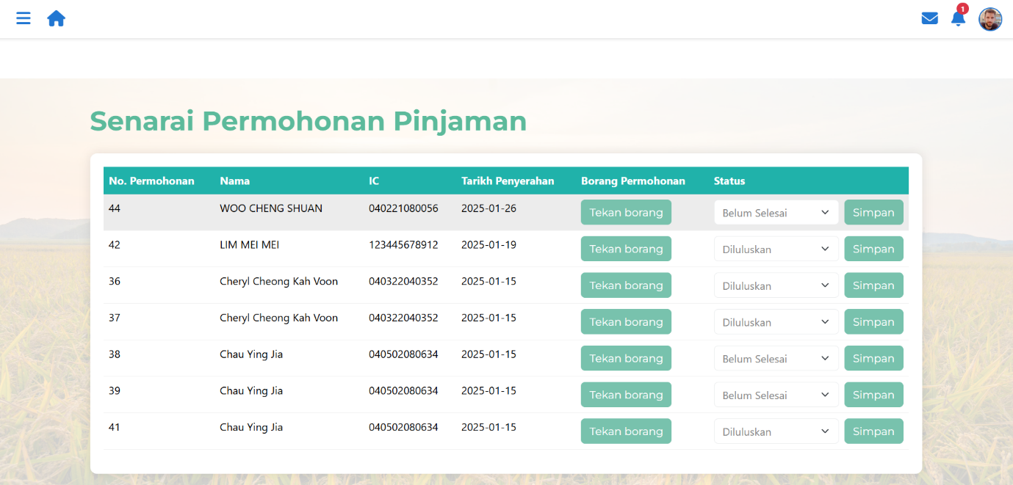

SECTION D (CONCLUSION AND REFLECTION)

4.1 Conclusion

In conclusion, the implementation of automated alert and notification module is successfully addressed the primary shortcomings of the original system. The automated alert mechanism ensures that administrators are promptly notified about pending approvals for member registrations and loan applications to reduce delays and improve response times. Also, members and users are able to receive real-time updates on their application statuses, which minimizes uncertainty and builds trust in the system. As a suggestion for future improvement, developers can develop a mobile app version of the system to enhance accessibility and provide push notifications for better user engagement.

4.2 Reflection

In this WBL project, we started this project with our lecturer, stakeholders and team members from last semester and continued it into this semester. The project involved documentation, design, implementation and development of a digital platform for Koperasi KADA, focusing on member registration and loan application processes. Our team consisted of five members collaborating on this project. We shared the workload for every part of the progress, whether documentation, database or development to ensure everyone knew the details and learned from the experience.

I felt motivated and excited to contribute to the project initially since it’s the first time building a new system from scratch. However, I have to admit that my technical skills were not strong enough, so I felt a mix of stress and pressure to deliver a working module on time as the deadlines approached. Luckily, I had a supportive and mentally strong team who ensure all members stayed on tracks and finished the work excellently and on time. There were resource constraints for us, such as stakeholders sometimes not responding to our questions which created unknown situation to solve.

The positive experience was that we successfully implemented a functional system that addressed the project’s goals. The collaborative environment fostered teamwork and feedback from the lecturers helped improve our approach. However, the negative experience was we didn’t ensure our steps were correct before moving to the next ones. This was due to poor time planning and we had no choice but to proceed with our decisions regardless. My feelings of stress and urgency likely impacted my approach to task prioritization but I didn’t delay my work scope. I was still able to focus on the work, though in a worse situation. The positivity of the team led me to a better thoughts and motivated me to work harder. However, I can’t let the people around me distract me too much. I need to learn how to stay on track and do my best, even in a stressful environment. Also, I need to improve communication with my teammates.

I chose to reflect on this project because it highlights the importance of balancing technical responsibilities with team collaboration and communication. The reflection made sense given the challenges we faced, such as tight deadlines and limited resources which influenced out ability to perform effectively. The main area of concern is improving time management and ensuring better coordination within the team. Effective communication and contingency planning are crucial to avoid delays and misaligned efforts in future projects.

Through this project, I discovered the importance of having a well-structured project plan with clear task assignments and realistic timelines. I learned that frequent communication between teammates and stakeholders is essential when developing a new system. However, questions remain about how to effectively manage unexpected challenges such as technical difficulties or resource shortages without derailing the project timeline.

To improve my practice for the next time, I will develop a detailed contingency plan to handle unexpected challenges. I will also prioritize communication and progress checks with my teammates. I might need help with training in project management and guidance from supervisors on handling unforeseen issues.

